**NATIONAL ACADEMY OF**

**SCIENCE AND TECHNOLOGY**

**Dhangadhi-04, Uttarbehadi**

*(Affiliated to neb)*

A Collection of Projects

**Submitted in partial fulfillment of the requirements for the Grade 11 Science in English**



Submitted To: Submitted By:

Mr. Upendra Bahadur Bam Amrit Pant

Lecturer of English Class 11

Principal NAST Section F

**ACKNOWLEDGEMENT**

Any achievement, be it scholastic or otherwise, does not depend solely on individual efforts but on the guidance, encouragement, and cooperation of intellectuals, elders, and friends. We would like to take this opportunity to thank them all.

First, we would like to thank the NAST for providing us with all the requirements for our project.

We are grateful to acknowledge the guidance and encouragement that has been given to us **Mr. Upendra Bahadur Bam, Lecturer**, English, NAST, Dhangadhi, has rendered valuable assistance and guidance.

We also extend our thanks to the entire faculty of the **Department of English,** NAST, Dhangadhi, who have encouraged us throughout the course of the project.

Last but not least, we would like to thank our family and friends for their input in improving the project.

| **Name: Amrit Pant** | **Roll Number: 05** |
| --- | --- |
|  |  |
|  |  |
|  |  |
|  |  |

**DECLARATION**

I am Amrit Pant, a student of Class 11 of the Science Group of NAST affiliated with NEB, hereby declaring that the works undertaken in this report are the outcome of my own effort and are correct to the best of my knowledge. This work has been accomplished by obeying social ethics. It contains neither materials published earlier or written by another person/people nor materials which have been accepted for the award of any other degree of the school or other institution, except where due acknowledgment has been made in the document

**Amrit Pant**

**CERTIFICATE**

This is to certify that the reports of the project are carried out by **Amrit Pant**  under the guidance and supervision of Mr. Upendra Bahadur Bam for the partial fulfillment of the secondary school grade XI certificate level degree of English by the National Examination Board.



To the best of our knowledge and belief, this work embodies the work of the candidates themselves, has duly been completed, fulfills the requirement of the ordinance relating to the Grade XI degree of the school, and is up to the standard in respect of the content, presentation and language for being referred to the examiner.

| **Mr. Upendra Bahadur Bam** | **Mr. Krishna Bhandari** |
| --- | --- |
| Lecturer, English | HOD, Science |
| NAST | NAST |
| Dhangadhi, Kailali | Dhangadhi, Kailali |
| ………… | ………… |
| **Signature** | **Signature** |

………………………...

Mr. Upendra Bahadur Bam

**Principal**

**NAST**

**Table of Contents**

| *s.n* | *Topic* | *Remarks* |
| --- | --- | --- |
| 1 | The Impact of Russia Ukraine war on the world |  |
| 2 | Project work on Balbhadra Kunwar |  |
| 3 | The Comparison and Differences between QIN Dynasty and Rana Regime |  |
| 4 | Essay about soul by Swami Vivekananda |  |
| 5 | The Life of King Birendra and His Contribution to Nepal |  |
| 6 | To study the impacts of superstition in the society |  |
| 7 | The Pictures that shows lifestyle of Nepalese People |  |
| 8 | Project work on History of Amar Singh Thapa |  |

**PROJECT 1**

IMPACT OF RUSSIA UKRAINE WAR

**Table of Contents**

1. Introduction………..…………………………….………...5
2. Food Security Challenge in Ukraine……………….……6
3. Chances of World War 3.……….…..……………………7
4. Conclusion………………………...……………….……...9
5. References …………………..…………………………..11

**Introduction**

The war that began on 24 February 2022 has caused extensive damage and loss of life in major cities in Ukraine, spread across rural areas, and sparked massive population displacement.

More than 3.6 million people had been forced to abandon their homes and flee across borders to safety. Millions more are internally displaced. It is clear that the war has resulted in a massive, and more deteriorating, food insecurity situation, disrupted livelihoods during the agricultural growing season in Ukraine, and has also affected global food security. Already prior to the war in Ukraine, international food commodity prices had reached an all-time high. This was mostly due to market conditions, but also high prices of energy, fertilizers, and all other agricultural services. The conflict has aggravated the situation. In March 2022, the FAO Food Price Index reached a new historical record high, up 12.6 percent from February and 33.6 percent from its level a year earlier, and 15.8 percent higher than the peak reached in February 2011. The Russian Federation and Ukraine are prominent players in the global trade of food and agricultural products. In 2021, wheat exports by the Russian Federation and Ukraine accounted for about 30 percent of the global market. Russia’s global maize export market share is limited, standing at 3 percent between 2016/17 and 2020/21. Ukraine’s maize export share over the same period was more significant, averaging 16 percent and conferring it the spot of the world’s 4th largest maize exporter. Combined, sunflower oil exports from both countries represented 78 percent of the global supply. The Russian Federation is also a key exporter of fertilizers. In 2021, it ranked as the top exporter of nitrogen fertilizers, the second leading supplier of potassium, and the third largest exporter of phosphorous fertilizer in the world.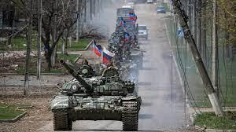

Nearly 50 countries depend on the Russian Federation and Ukraine for at least 30 percent of their wheat import needs. Of these, 26 countries source over 50 percent of their wheat imports from these two countries. In that context, this war will have multiple implications for global markets and food supplies, representing a challenge for food security for many countries, especially for low-income food import-dependent countries and vulnerable population groups

**FOOD SECURITY CHALLENGE**

The war in Ukraine has already caused extensive damage and loss of life in key population centers, spread across rural areas, and sparked massive population displacement. Populations in active war zones are facing severe shortages of food, water, and energy supplies. As insecurity persists and both local and national supply chains are disrupted, people are likely to fall deeper into hunger and malnutrition. . Key immediate areas of concern include:

• disruption to winter harvesting and spring planting;

• agricultural labor availability, impacted by displacement;

• access to and availability of agricultural inputs, particularly fuel, and seeds;

•Diisruption of logistics and all elements of the food supply chains;

• abandonment of and reduced access to agricultural land; • damage to crops due to military activity, especially during vegetative

• destruction of agrifood system assets and infrastructure.

**Chances of WW3**

Russia’s unprovoked war with Ukraine recently entered its eighth month, and there are few signs of it ending anytime soon.

Rather, the fighting appears more likely to escalate. Russian President Vladimir Putin announced last week that he will push 300,000 reservists into service, and his accompanying speech featured some alarming threats. Referencing – without evidence – that the West is engaging in “nuclear blackmail” against Russia, the leader noted that his country “has various means of destruction” and, when threatened, “will certainly use all the means” at their disposal, according to a translation. This comes after Russia reportedly engaged in provocations near a Ukrainian nuclear power plant in August, which a U.S. Department of Defense official described as the “height of irresponsibility.”

A stark new finding from an international survey suggests that the world is taking these threats – and their broader global implications – seriously.

In a study of more than 17,000 people across the world, three-quarters of respondents agreed with the statement, “I fear we are moving closer to World War III.” The findings are culled from the U.S. News & World Report Best Countries survey, which was fielded this year from April 30 to July 13 and is used for annual, perception-based rankings of countries.

**Conclusion**

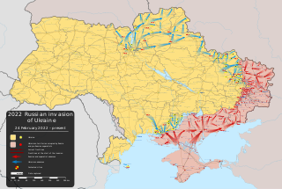

In conclusion, We have to understand that war can never be won completely by a single nation, both nations suffer from severe damage to people and infrastructure. War can also lead to the mass destruction of mankind. To protect and preserve mankind and promote peace we should stand against war and try to stop it.

**References**

<https://www.wikipedia.org>

<https://www.usnews.com> <https://www.youtube.com>

**PROJECT 2**

Project work on Balabhadra Kunwar

**Contents**

INTRODUCTION 6

Name 6

FAMILY AND EARLY LIFE 6

THE ANGLO NEPAL WAR 1814-1816 7

UNDER MAHARAJA RANJIT SINGH 10

UNDER HARI SINGH NALWA AND DEATH 10

REFERENCES 10

# **INTRODUCTION**

Balbhadra Kunwar was born in Magh 17 1845 BS.  He was born in Kathmandu. Balbhadra Kumar’s father is Chandrabir Kumar and his mother is Ambika Devi. Ambika Debi Badakaji was the daughter of Amar Singh Thapaki. That is, Bal Bhadra Kumar was the grandson of Amar Singh Thapa. Babu Chandra Vir was a soldier in the Nepal Army. Balbhadra Kunwar also joined the Nepal Army. And became a subedar at the age of seventeen. He had reached Kumaon during his military service.He was a Gorkhali military commander and administrator in the Kingdom of Nepal. He is one of the National Heros Of Nepal.He was highly praised for his military skill for the defence of Nalapani Fort in the Anglo Nepalese War (1814–1816). He was Captainin the Nepalese military and was tasked as commander to protect the forts of  Dehradun.

## **Name**

His given name Junge is the name of Baladeva (BALARAM), the elder brother of Krishna.

### **FAMILY AND EARLY LIFE**

He was born to father Chandrabir Kunwar, a resident of Bhanwarkot of Panchkhal Municipality in Kavrepalanchowk District. His mother Ambika Devi was a sister of Kaji Ranajor Thapa and daughter of Bada Amar Singh Thapa. His father Chandrabir was son of Jaya Krishna Kunwar and grandson of Ashiram Kunwar. His brother Birabhadra Kunwar was military commander in Kumaun and Kangra front (1809 A.D.) as well as governor of Garhwal.

# **THE ANGLO NEPAL WAR 1814-1816**

As commander of the Gorkhali forces in Dheradun, Capt. Balbhadra Kunwar was handed the responsibility of defending the area. The expanding Nepali/Gorkhali State had since the mid-late 18th century expanded the nation's border on all sides, which eventually led to conflict with the British East India Company and a war followed.

Realizing he could not defend the town of Dehradun, Capt. Balbhadra Kunwar withdrew to the strategic hill fort of Khalanga with an army strength of 600 including women and children against the British East India Company British stronghold of 3000–3500 troops. He turned down an incentive proposal of the British who would make him Governor of the Western Garhwal should he surrender or leave Nepal.In the month of October 1814, Major General Sir Rollo Gillespie of the British army had advanced along with 3,500 troops and eleven pieces of cannon to occupy the Nepali territories situated between the Ganges and Yamuna rivers in the Gharwal and Kumaon regions that had been occupied by the Nepali forces. Captain Balabhadra Kunwar had maintained his position at a 400 cubits high hill in a place called Nalapani, situated north-east of Dehradun, to check his advance.

On Kartik 8, 1871, Bikram Samvat (October 1814), British troops reached Dheradun. A battle took place between British and Nepali troops at Nalapani on Kartik 10, 1871 B. Samvat. The British were unsuccessful and withdrew to Dehradun. Another battle was fought between the two sides at Nalapani on Kartik 17, 1871 Samvat (ca. Oct 31, 1814). General Gillespie, the British Commander, lost his life in that battle along with Col. Alice.

The siege continued for a month until the British, convinced that they could not win by military ways, blocked the source of water to the fort so that the Nepalese would die of thirst. For the Nepali Army it was a hard struggle fighting a very well equipped and trained modern army, belonging to one of the largest colonial Empires of the world. Balbhadra Kunwar had asked for reinforcements from the capital but Kathmandu could not send them any soldiers as the Nepali army had no reserve army and were an emerging power which means that they did not have troops to match the East India Company. The Nepalese army was outnumbered in Nalapani as it was in every battlefield.

Even though the Nepali army lacked water they were still determined to defend their position. Because the walls had collapsed, cannonballs fired by the British started reaching the interior of the fort. Many men were killed or injured. Despite losing their comrades and friends the remaining men were still determined to defend their position. In order to drink water from the river they came out of the fort in a single line, and the British forces watched in surprise as the Nepali troops quenched their thirst and returned to their fort.

On Marga 16 (Nov 1814), four of the commanders, including Capt. Balabhadra Kunwar, in the night was forced to abandon the fort of Nalapani with their remaining Gorkhali troops. On seeing the Nepalis abandon the fort, the British attacked them. The Nepalis resisted the attack but continued to advance. They reached Dwara in the morning of Marga 17, 1871 and stayed the whole day there.

Balabhadra sent a courier to the British with the following message: We had handed over to you your dead and injured soldiers on your request. We now request you to hand over our injured soldiers to us. The British replied that they would look after the injured (Nepali) soldiers themselves. Accordingly, they treated the 180 injured soldiers at the Nalapani fort.

The next day, Marga 18, 1871 Samvat, the Nepalis left Dwara for the Gopichand Hill, where they had decided to build a fort. Dwara was not considered suitable for that purpose.

The Nepalis spent the night at the Gopichand hill. At midnight, the British forces started shelling their camp. The Nepalis retaliated. Meanwhile, Sardar Ripumardan Thapa sustained an injury in his right arm from an enemy shell. He was unable to walk, and so was helped by his jamadar to climb the hill. However, he could not go on and was forced to stop. The other Nepalis continued to ascend the hill.

The next day, Marga 19, 1871 B. Samvat, men sent by Balabhadra carried Ripumardana to Chamuwa. Kaji Ranadipa Simha Basnyat also had arrived at that place. On Marga 20, Kaji Rewanta Kunwar reached there Subedar Dalajit Kanwar were killed by enemy fire.

Ultimately after 4 days of thirst, and a severe loss of troops, without surrendering, Capt. Balbhadra emerged from the fort with drawn kukris in his hands (along with other 70 survivors) and roared to the British – "You could have never won the battle but now I myself voluntarily abandon this fort. There is nothing inside the fort other than dead corpses of the children and women"! He and his remaining troops escaped into the hills on November 30, 1814.

A peace treaty was signed on Dec 2, 1815 between the then King Girvan Yuddha Vikram Shah and the British East India Company, known as the Sugauli Treaty.

# **Capture.PNG**

## **UNDER MAHARAJA RANJIT SINGH**

He did not lose his life during the Anglo-Nepalese war. After the war, he went to Lahore, capital of the Punjab where many Nepalis had gone, to join the two new regiments formed by the Sikh Maharajah Ranjit Singh of the Punjab, following the war with the British but a tradition formed prior to the war.Capt. Balbhadra Kunwar was appointed General and commander of the new "Goorkha" regiments consisting entirely of Gorkhali/Nepali troops. Those that had taken service under the Mughal Emperors were known as "Munglane" and was seen as very powerful.

### **UNDER HARI SINGH NALWA AND DEATH**

During the Sikh-Afghan war of 1879 BS (1822), the Nepalis in the Sikh Military had fought bravely, but was also in which Balabhadra Kunwar was killed by Afghan artillery in Naushera, Peshawar region, Afghanistan on Chaitra 3 (March/April in the Roman calendar and is the last month in the Hindu Lunar calendar). Bhimsen Thapa had sent men to Lahore to collect information about this war and the death of his nephew. He was under the great and famed General Hari Singh Nalwa who honoured him during the battle. Hari Singh Nalwa continued the campaign and reached as far as Jamrud.

Following the Anglo-Nepali War, the British East India Company erected a war memorial at Nalapani in honor of the Gorkhalis and Capt. Balbhadra Kunwar (often referred to wrongly as Bulbuder Singh or Balbudder Thapa) praising their bravery.

# 

# **REFERENCES**

[1][**https://en.wikipedia.org/wiki/Balbhadra_Kunwar**](https://en.wikipedia.org/wiki/Balbhadra_Kunwar)

[2][**http://kathmandupost.ekantipur.com/printedition/news/20[12-01-31/bulbudder-and-the-british.html**](http://kathmandupost.ekantipur.com/printedition/news/20%5b12-01-31/bulbudder-and-the-british.html)

[3][**http://www.imnepal.com/national-heroes-nepal/**](http://www.imnepal.com/national-heroes-nepal/)

**PROJECT 3**

Comparison and Differences between Qin Dynasty and Rana Regime

**Table of Contents**

1. Introduction to QIN Dynasty..…………………….…………...5 2. Introduction to Rana Regime …………..…..……...…………6 3. Similarities between QIN and Rana…………..…….………..7 4. Differences between QIN and Rana…...……………..……...8 5. Conclusion.…….……………..………………………………..11

**Introduction to Qin Dynasty**

The Qin Dynasty (221-206 BCE) was a brief but significant period in ancient Chinese history. It marked the first time China was united under a single ruler and centralized government. The dynasty was founded by the ambitious ruler Qin Shi Huang, who became king of the state of Qin at the age of 13 and went on to conquer the other six states and unify China.

Qin Shi Huang is best known for his massive building projects, including the Great Wall of China and his lavish tomb complex, which famously contains an army of terracotta warriors. He also standardized the written script, currency, weights and measures, 

and laws throughout his empire. However,

his rule was also characterized by

authoritarianism, censorship, and the

persecution of his critics.

The Qin Dynasty was also a time of

significant cultural and intellectual

development. Confucianism, Taoism, and

Legalism all emerged or gained prominence during this period, and the era saw the creation of many important works of literature, philosophy, and history.

Despite its short duration, the Qin Dynasty profoundly impacted Chinese history and laid the foundation for many of the political and cultural traditions that would shape China for centuries to come.

**Introduction to the Rana Regime**

The Rana Regime of Nepal, also known as the Rana dynasty, was a period of authoritarian rule that lasted from 1846 to 1951. During this time, a small group of hereditary prime ministers known as the Ranas wielded absolute power over Nepal, while the monarchy

was reduced to a ceremonial role. 

The Rana family first came to power in

Nepal in 1846 after a palace coup that

overthrew the existing monarchy. From

that time on, the Ranas held the real

power in the country and ran the

government in an autocratic fashion. The

regime was characterized by its

repression of political opposition,

censorship, and a lack of democracy.

*Fig. Janga Bahadur Rana*

Despite these authoritarian tendencies, the Rana period also saw some important modernization and infrastructure development in Nepal. The Ranas built roads, introduced electricity, and modernized the military, among other things.

The Rana regime finally came to an end in 1951, when a popular uprising led by political parties and supported by the Nepalese monarchy forced the Ranas to step down and restore the monarchy to its traditional role as the nominal head of state. The end of the Rana regime paved the way for greater political freedom and the eventual establishment of a democratic government in Nepal.

**Similarities between Qin and Rana:**

- Both the Qin Dynasty and the Rana regime were characterized by authoritarianism and centralized government control.

- In both cases, a small ruling elite held the reins of power and made decisions on behalf of the larger population.

- The rulers of both regimes were known for their building projects and infrastructure development, with Qin Shi Huang constructing the Great Wall of China and the Ranas building roads and introducing electricity in Nepal.

- In both dynasties, people were deprived of basic human right. - There were no education and people were forced not to read books or any educational materials.

- Both Qin and Rana are highly power-hungry dynasties who always wanted absolute power.

- Both the Qin Dynasty and the Rana regime relied heavily on centralized control and powerful military to maintain their rule. - In both cases, the ruling elites were known for their lavish lifestyles and the construction of grand palaces and monuments.

- Both the Qin Dynasty and the Rana regime faced significant internal opposition and were prone to using violence and repression to quell dissent.

- The leaders of both regimes were seen as controversial figures in their time, with Qin Shi Huang being remembered both for his contributions to Chinese unification and his harsh rule, while the Rana family is seen by some as responsible for stalling Nepal's development during the 19th and early 20th centuries.

**Differences between Qin and Rana:**

- The Qin Dynasty was a much earlier period than the Rana regime, with the Qin Dynasty lasting from 221-206 BCE and the Rana regime lasting from 1846 to 1951.

- The Qin Dynasty united a large and diverse territory into a single Chinese empire, while the Rana regime maintained control over a smaller, mountainous kingdom in Nepal.

- While the Qin Dynasty saw significant cultural and intellectual development, with the emergence of Confucianism, Taoism, and Legalism, the Rana regime was characterized more by repression of political opposition and a lack of democratic institutions.

- The end of the Rana regime saw a transition to democracy in Nepal, while the end of the Qin Dynasty led to a period of political fragmentation and division in China.

- There was a puppet or ceremonial king system in Rana’s Period, Whereas there was no such system in QIN.

**Conclusion:**

The Rana regime of Nepal and the Qin Dynasty of China were two very different historical periods, separated by geography, culture, and time. However, there were some notable similarities between the two. Both were characterized by centralized control and a powerful ruling elite, who were known for their building projects and infrastructure development. They also faced significant internal opposition and were willing to use violence and repression to maintain their rule. However, there were also many differences between the two, including the size and scope of their territories, their political structures, and the cultural and intellectual achievements of their respective societies. Despite these differences, both the Rana regime and the Qin Dynasty continue to be studied and remembered for their impact on history.

**References:**

*https://www.wikipedia.org*

*https://www.google.com*

*https://www.youtube.com*

*English Book Class 11*

*Class 9 and 10 social Book*

**PROJECT 4**

Essay about soul by swami Bibekananda

**Contents**

Essay on Immortality, Chapter 13 of Jnana Yoga by Swami Vivekananda 6

REFERENCE 7

# **Essay on Immortality, Chapter 13 of Jnana Yoga by Swami Vivekananda**

By Patrick Horn (“Rishi”)

Swami Vivekananda says, “The whole of this life which slowly manifests itself evolves itself from the protoplasm to the perfected human being — the Incarnation of God on earth — the whole of this series is but one life, and the whole of this manifestation must have been involved in that very protoplasm. This whole life, this very God on earth, was involved in it and slowly came out, manifesting itself slowly, slowly, slowly.”  A serious seeker doesn’t leave the possibility of realizing latent potential to chance. Initiation with right guidance accelerates the evolutionary process to a definite end.

In the first initiation, the body is disciplined, its impulses transmuted, and conduct reoriented toward wisdom and spiritual principles. The needs of the body for food, drink, sleep, and sex do not dominate. The aspirant moderates desire and espouses vegetarianism. Ideals of duty and mercy become strong. In the second initiation, emotional life is stabilized. The ignorance and confusion of fear and vanity is clarified and overcome through withdrawal from the senses and non-attachment. The soul is no longer stifled by animal instincts, conditioned reactions, and habituated opinions. There is no distress arising from shame, aversion, or the need to control. Sincere devotion and steady effort nurture altruism and free an initiate from burdens of the heart and distortion of thought.

In the third initiation, intellectual life is developed, and character becomes mindful and virtuous. By a logical method of inquiry and investigation, the initiate arranges facts, observes patterns in accord with principles, and applies knowledge in the creative expression of wisdom. There is mastery of numbers, forms, and harmonics. The philosophical apprentice gains abstract and practical knowledge of minerals, plants, animals, and astronomy. Symbolic intuition is acquired in the discovery of relationship between macrocosm and microcosm. The soul discerns the unreal from the Real in the first perceptions of unchanging original Truth.

In the fourth initiation, false identity is retired, as are the masks worn for the common roles of society and economic flattery. The initiate is no longer motivated by money, status, or pleasant sensations. Life is generously dedicated to a noble purpose and given meaning through the study of religion and esoteric knowledge. Meditation and other advanced spiritual practices are integrated into daily routines. The soul is done with suffering in the cycles of phenomenal appearances and seeks freedom in the permanent joy and peace of the numinous eternal. The disciple perceives the unity and order of the cosmos and gains in divine perfection.

In the fifth initiation, the novice becomes the Master of the worlds of sense-desires, pure forms, and formless Truth. The veil of existence is perceived as the timeless play of the immortal Absolute free from causality. The soul is beyond disease and decay with extraordinary knowledge of the past, the future, and the invisible processes of Nature. With skillful means and fully-realized mind-powers, the adept may act as a figure-of-history and person-of-destiny to introduce new values and lifestyles to society. The evolutionary goal is thus achieved.

# **REFERENCE**

**[1] https://vedantaprov.org/essay-on-immortality-chapter-13-of-jnana-yoga-by-swami-vivekananda/**

**[2] www.vedantaprov.org**

**PROJECT 5**

The life of king Birendra and his contribution to Nepal

## **Introduction:**

Birendra was born at the Narayanhiti Royal Palace in Kathmandu as the eldest son of the then Crown Prince Mahendra Bir Bikram Shah Dev and his first wife, Crown Princess Indra Rajya Lakshmi Devi.

Birendra spent eight years studying at St Joseph's School, a Jesuit school in Darjeeling, with his brother Gyanendra. On 13 March 1955, their grandfather King Tribhuvan died and their father succeeded to the Nepalese throne. With his father's ascension, Birendra became the crown prince of Nepal.

## **Early Life:**

## Birendra was educated at St. Joseph’s College (Darjeeling, India), Eton College (England), Tokyo University (1967), and Harvard University (1967–68) and traveled extensively before acceding to the throne on his father’s death on January 31, 1972. (He was crowned on February 24, 1975.) Birendra continued the autocratic tradition of his father, who had dissolved the elected parliament in 1960 and banned political parties in the constitution of 1962; indeed, for a time, Birendra was one of the world’s few remaining absolute monarchs. He managed to maintain Nepal’s independence despite encroaching influences by India, China, and the Soviet Union. During his reign, Nepal was opened up to extensive tourism.

**GOOD WORKS OF KING BIRENDRA**

1. **International Relations**

I believe King Birendra was a nationalist whose main concern was the survival of the Nepali state more than anything. Under the rule of King Mahendra his father Nepal established diplomatic relations with many countries including China and steered a more independent foreign policy. King Birendra continued that by expanding diplomatic relations and under his reign Nepal even became a non-permanent member of the UN Security Council which was a major feat. So the first achievement I think is increasing the international profile.



fig. President Ronald Regan and King Birendra

The second important thing is maintaining Nepal's independence and preventing it from being another Bhutan. FYI Bhutan is a country whose foreign policy is essentially run by India so much so that it hasn't even established diplomatic relations with China. Back in 1990 AD with protests in Nepal for democracy, the Indian govt launched a blockade of Nepal and then sent a secret treaty to King Birendra where his absolute rule was guaranteed by the Indian govt if he just agreed to hand over Nepal's natural resources and foreign policy to India just like Bhutan. He said No and then gave up power to the people rather than be an absolute ruler supported by India just like Bhutan. This I believe is very important because power corrupts absolutely and King Birendra thought about Nepal first, not his own personal power.

**Promotion of peace**

He proposed Nepal be declared a zone of Peace in the United Nations meeting, taking into consideration Nepal's historic peace status, the birth of Gautam Buddha, and its historical policy of Non-alignment to any foreign powers. This proposal was supported by 116 countries in the UNO. He later established a "Peacekeeping Training Camp" in 1986. This was later restructured into a training institute in 2001 for training peacekeeping forces. It was later renamed as Birendra Peace Operations Training Centre. This institute was later restructured as the training organization through which Nepal started sending trained, peace-keeping forces in cooperation with the UN and became an active member of it. In 1974, King Birendra was successful in peacefully disarming the Khampas rebellions, and settling in the northern Himalayan region, by giving land, money, and citizenship to those who surrendered their arms, and by confiscating weapons as well.

**Environmental protection**

King Birendra was regarded as a lover of nature and a great supporter of nature conservation. The trend of nature conservation from the government started during his reign. The dramatic decline of the rhinoceros population due to massive Terai migration and the extent of poaching prompted the government to institute the Rhino Patrol force (Nepali: गैडा गस्ती ) of 130 armed men and a network of guard posts all over Chitwan. To prevent the extinction of rhinos through a legal system, the National park law was introduced

**Roads and Transportation**

Various Studies in 1972 showed that building road connectivity in hilly and rural areas was more expensive than air connectivity. So, the then government took the policy of connecting rural areas with airports and built roads only when there was a high amount of traffic flow. Under this policy, Baglung Airport (Balewa Airport), Dhorpatan Airport, Mahendranagar Airport, and Rukum Chaurjahari Airport were established in the year 1973. Sanfebagar airport was established in 1975. Simikot Airport was established on 18th March 1977, Dolpa Airport was established in 1978, and Ramechhap airport in 1979. Doti Airport, also known as Silgadhi Airport, was established in 1973 with a blacktopped runway. Talcha Airport, also known as Rara Airport was built in 1975. Taplejung Airport located in Phungling, also called Suketar Airport, Jiri Airport, Phaplu Airport, and Bajhang Airport was built in 1976. Rolpa Airport in 1980, Manang Airport in 1981, Bajura airport in 1984, and Darchula Airport in 1986.

**The dark side of king Birendra's**

**Stagnant economy**

Though King Birendra is remembered as a development-friendly king, he is also criticized for his inability to drive the country towards rapid development efforts like his father King Mahendra. He had the political will but simply not the skill through which development efforts could be rapidly gained. His policy of sustainable development, shown by his nature conservation efforts, culture, and history became hindrances to economic development. The Panchayat regime created a stagnant economy during his reign as an autocratic ruler.

**Administrative failure**

Historians point out that the Panchayat Regime under King Birendra was a failure. He was not able to bring in much direct foreign investment during his reign, and all the programs he brought, or all the reforms he made were the continuation of his father's legacy. He restructured various organizations previously established by his father and implemented various development plans envisioned by his father. However, he was not able to bring about a radical change in the country. Moreover, some historians also claim that making the cannabis trade illegal, implemented during this era, created mass unemployment which eventually became one of the causes of the Maoist revolution.

**Failed development efforts**

Birendra restructured various organizations and brought many development plans, but his development efforts were mostly a failure; which hindered any radical change in the country. Many airports and roads built during his era were rarely used, and eventually had to be closed down.

**Conclusion**

In conclusion, King Birendra was a person who worked for the country and tried to improve it but some of his policies were quite ineffective. He had also conducted a referendum, which pro-Democrats stated unethical and fraud. He was also a reason for the removal of the panchayat and the establishment of a constitutional monarchy. He played an important role in the development of Nepal. He is still considered a good and moral King.

**References:**

<https://wikipedia.org>

<https://google.com>

<https://youtube.com>

<https://washingtonpost.com>

**PROJECT 6**

TO STUDY ABOUT THE IMPACT OF SUPERSTITIONS IN THE SOCIETY

**TABLE OF CONTENTS**

**Chapter 1: Introduction**

**Chapter 2: Occurrence**

**Chapter 3: Different Types of Superstitions in Nepal**

**Chapter 4: Opposition to Superstition**

**Chapter 5: Impacts of Superstitions on Society and People**

**Chapter 6: Conclusion**

**Chapter 7: Acknowledgement**

**Chapter 8: References**

1. **Introduction:-**

A superstition is any [belief](https://en.wikipedia.org/wiki/Belief) or practice considered by non-practitioners to be [irrational](https://en.wikipedia.org/wiki/Irrational) or [supernatural](https://en.wikipedia.org/wiki/Supernatural), attributed to [fate](https://en.wikipedia.org/wiki/Fate) or [magic](https://en.wikipedia.org/wiki/Magic_(supernatural)), perceived [supernatural](https://en.wikipedia.org/wiki/Supernatural) influence, or [fear](https://en.wikipedia.org/wiki/Fear) of that which is unknown. It is commonly applied to beliefs and practices surrounding [luck](https://en.wikipedia.org/wiki/Luck), [amulets](https://en.wikipedia.org/wiki/Amulet), [astrology](https://en.wikipedia.org/wiki/Astrology), [fortune telling](https://en.wikipedia.org/wiki/Fortune_telling), [spirits](https://en.wikipedia.org/wiki/Spirit_(animating_force)), and certain [paranormal](https://en.wikipedia.org/wiki/Paranormal) [entities](https://en.wiktionary.org/wiki/entity), particularly the belief that future events can be foretold by specific (apparently) unrelated prior events.

Also, the word superstition is often used to refer to a religion not practiced by the majority of a given society regardless of whether the prevailing religion contains alleged superstitions or to all religions by the [antireligious](https://en.wikipedia.org/wiki/Antireligion).

Definitions of the term vary, but commonly describe superstitions as irrational beliefs at odds with scientific knowledge of the world. [Stuart Vyse](https://en.wikipedia.org/wiki/Stuart_Vyse) proposes that a superstition's "presumed mechanism of action is inconsistent with our understanding of the physical world", with Jane Risen adding these beliefs are not merely scientifically wrong, but impossible. Similarly, Lysann Damisch defines superstition as "irrational beliefs that an object, action, or circumstance that is not logically related to a course of events influences its outcome", [Dale Martin](https://en.wikipedia.org/wiki/Dale_Martin_(scholar)), says they "presuppose an erroneous understanding about cause and effect, that have been rejected by modern science." The [Oxford English Dictionary](https://en.wikipedia.org/wiki/Oxford_English_Dictionary) describes them as "irrational, unfounded", [Merriam Webster](https://en.wikipedia.org/wiki/Merriam-Webster), as "a false conception about causation or belief or practice", the [Cambridge Dictionary](https://en.wikipedia.org/wiki/Cambridge_Advanced_Learner%27s_Dictionary) "sans grounding in human reason or scientific knowledge". This notion of superstitious practices are not causally related to the outcomes.

Both Vyse and Martin argue what is considered superstitious varies across cultures and time. For Vyse, "if a culture has not yet adopted science as its standard, then what we consider magic or superstition is more accurately the local science or religion." Dale points out that superstitions are often considered as out of place in modern times influenced by modern science and its notions of what is rational or irrational, surviving as remnants of older popular beliefs and practices.

1. **Occurrence:-**

People tend to attribute events to supernatural causes (in psychological jargon, "external causes") most often under two circumstances.

1. People are more likely to attribute an event to a superstitious cause if it is unlikely than if it is likely. In other words, the more surprising the event, the more likely it is to evoke a supernatural explanation. This is believed to stem from an effectance motivation - a basic desire to exert control over one's environment. When no natural cause can explain a situation, attributing an event to a superstitious cause may give people some sense of control and ability to predict what will happen in their environment.
2. People are more likely to attribute an event to a superstitious cause if it is negative than positive. This is called [negative agency bias](https://en.wikipedia.org/wiki/Negativity_bias#Attribution_of_Intentions). Boston Red Sox fans, for instance, attributed the failure of their team to win the world series for 86 years to the [curse of the bambino:](https://en.wikipedia.org/wiki/Curse_of_the_Bambino) a curse placed on the team for trading Babe Ruth to the New York Yankees so that the team owner could fund a Broadway musical. When the Red Sox finally won the world series in 2004, however, the team's success was attributed to the team's skill and the rebuilding effort of the new owner and general manager. More commonly, people are more likely to perceive their computer to act according to its own intentions when it malfunctions than functions properly.

People seem to believe that superstitions influence events by changing the likelihood of currently possible outcomes rather than by creating new possible outcomes. In sporting events, for example, a lucky ritual or object is thought to increase the chance that an athlete will perform at the peak of their ability, rather than increasing their overall ability at that sport.

Psychologist [Stuart Vyse](https://en.wikipedia.org/wiki/Stuart_Vyse) has pointed out that until about 2010, "[m]ost researchers assumed superstitions were irrational and focused their attentions on discovering why people were superstitious." Vyse went on to describe studies that looked at the relationship between performance and superstitious rituals.

1. **Different Types of Superstitions in Nepal:-**

Even during today’s world of science and facts, Nepali society is still inclined towards a few beliefs without substantial evidence of realism. The beliefs, or superstitions, are unwritten and unproven rules that humans have made and follow. The older generation is heavily inclined in believing and following them, either citing fear of the power of the almighty or the unknown.

Neither the lack of origins nor the lack of information has stopped people from blindly following these beliefs. Some of the commonly believed superstitions indicate the good or the bad omens and it ranges from things, animals, behaviours to time of the day.

So, here are some common superstitions that every Nepali has grown up with:

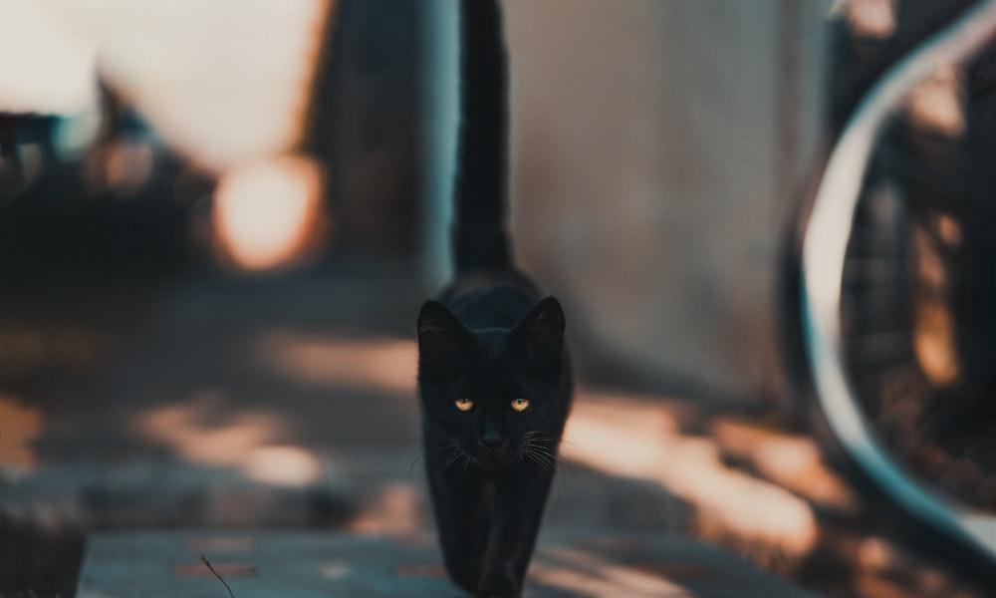

1. **Animal-based superstitions**
2. A cat crossing your way: If a cat, black in particular, crosses your way, it is a belief that you should not cross that [hypothetical] line on the road until something else passes that way. It is believed to bring you bad luck. But, if you are in a rush, it is considered okay to throw a stone and walk past the line.
3. Sound of dog’s howling: It is said if a dog cries in front of your house, someone will die from the family. So, everyone can be seen stopping it.
4. **Superstitions about things**
5. Looking at upside-down shoes or sandals: If you are going out or have something important to do, and on the way out, you see any upside-down sandals or shoes, this is believed to ruin your work. It is another form of bad luck. One should always turn them back before leaving.
6. Seeing empty jar or utensils: If you see an empty jar before going to an office or leaving the house for anything, it is believed you will have a bad day ahead and it will ruin your work. Similarly, the belief is that [seeing broken utensils or earthen pots](https://english.onlinekhabar.com/a-dying-tradition-of-kathmandu-in-which-locals-smash-pots-here-and-there.html) also ruins the work.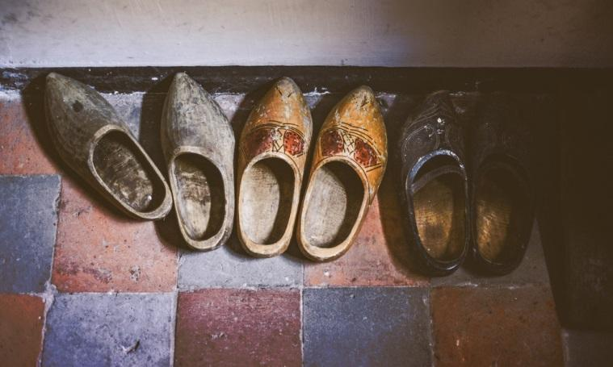
7. Cutting nails at night: If you cut nails at night, something bad will happen. Your elders scold you whenever you cut your nails at night. Some believe misplacing the cut nails means one will misplace the wealth too or ruin their work.
8. Spitting in a clump of hair before throwing: It is believed one should always spit in a clump of hair before throwing it away because many believe it refrains you from the harm from a witch. Besides that, if a bird makes a nest with that hair, it is believed the person will get ill.
9. Leaping over a broom: It is believed leaping over a broom creates bad luck and also, you will be a victim of sin.
10. Sitting on a pillow: It is said that if you sit on the pillow, you will have a headache.
11. Stepping on or over a book: Books are worshipped as a form of Goddess Saraswati, the goddess of knowledge. When one steps on or over a book, it is believed that they will lose knowledge. So whenever one steps on a book, they are expected to bow their heads in front of the respective book, seeking forgiveness.
12. Gifting a mirror: One should not give a newly married couple a mirror. Gifting a mirror to a married couple is believed to ruin their married life.
13. Bathing by wearing clothes: If one washes their hair while wearing clothes (of course, expect the undergarments), it is believed you will have bad luck. This is because only a person whose parents have died can wash their hair by wearing a dress, which is one of the customs during final rites.
14. **Superstitions around travel**
15. Sneezing while travelling: If you sneeze before travelling for a business deal or any other important work, sneezing before leaving for work symbolises bad luck as well.
16. Asking someone ‘where are you going?’: It is believed if someone asks you, “Where are you going?” just before leaving the house, this is believed to bring problems in your work.
17. Travelling on Tuesdays: If a person travels or comes back home on Tuesdays, it is believed there will be a fight between the partners or with any other family members. So, most of the Nepalis avoid their travel on Tuesdays.
18. Mothers and daughters separating on Saturdays: It is believed if mother and daughter separate on Saturdays, both of them will fall sick. Individual travelling on Saturdays are also believed to be a bad luck.



1. **Superstitions about food**
2. Eating dinner by sitting on the bed: Most Nepalis believe that if you eat your dinner by sitting on a bed, you will see bad dreams.
3. Cooking odd number of dishes: It is believed if you are making something, you should not turn off the stove without making an even number of dishes. Here, cooking an odd number of foods also symbolises bad luck.
4. Hanging chillies and lemon: Inside the business or shops, one can see people hanging some chillies and lemon on the doorstep. Hanging chillies and lemon is believed to protect the owner and business from bad spirits.

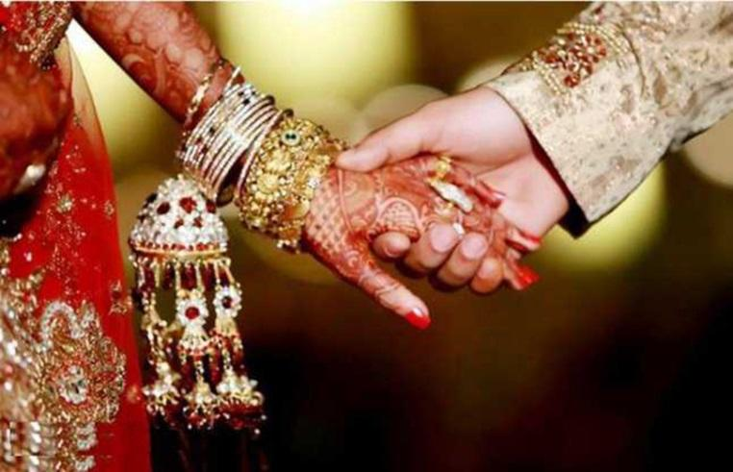

1. **Time-based superstitions**
2. Starting a business during a [malamas](https://english.onlinekhabar.com/mala-maas-why-is-dashain-one-month-away-from-sohra-shraddha-this-year.html): If one starts a business in a month of malamas, an extra lunar month in the calendar that comes every three years, it is believed it will not go longer and also one cannot get success.
3. Newlyweds staying together in the first malamas: If a newly married couple stays together or has sex during the month of malamas, it is believed to affect or shorten the life of the husband. It is also said that if they conceive during this month, an unhealthy child will be born. This is why there is a ritual that new brides spend their first malamas at their parents’ home, away from their husbands.
4. Whistling inside home/office: If you whistle inside the home, you are sure to have been scolded by your mom. It is believed when you whistle, the wealth from your home/office will go out. Another belief surrounding it is the whistling invites snakes to the home.
5. Shaving or cutting hair on birthdays: One should not shave or cut their hair on birthdays as people believe this will lead to shortening of one’s life span or s/he might get ill.
6. Giving birth on a new moon: It is believed that if a woman gives birth on the new moon (aunshi), people believe the child will not have good luck in life.
7. **Opposition to Superstition:-**

In the [classical era](https://en.wikipedia.org/wiki/Classical_antiquity), the existence of gods was actively debated both among philosophers and theologians, and opposition to superstition arose consequently. The poem [De rerum natura](https://en.wikipedia.org/wiki/De_rerum_natura), written by the Roman poet and philosopher [Lucretius](https://en.wikipedia.org/wiki/Lucretius) further developed the opposition to superstition. [Cicero](https://en.wikipedia.org/wiki/Cicero)'s work [De natura deorum](https://en.wikipedia.org/wiki/De_natura_deorum) also had a great influence on the development of the modern concept of superstition as well_as_the_word_itself. Where [Cicero](https://en.wikipedia.org/wiki/Cicero) distinguished superstitio and religio, [Lucretius](https://en.wikipedia.org/wiki/Lucretius) used only the word religio. [Cicero](https://en.wikipedia.org/wiki/Cicero), for whom superstitio meant “excessive fear of the gods” wrote that “superstitio, non religio, tollenda est ”, which means that only superstition, and not religion, should be abolished. The [Roman Empire](https://en.wikipedia.org/wiki/Roman_Empire) also made laws condemning those who excited excessive religious fear in others.

During the Middle Ages, the idea of God's influence on the world's events went mostly undisputed. [Trials by ordeal](https://en.wikipedia.org/wiki/Trial_by_ordeal) were quite frequent, even though [Frederick II](https://en.wikipedia.org/wiki/Frederick_II,_Holy_Roman_Emperor) (1194 – 1250 AD) was the first king who explicitly outlawed trials by ordeal as they were considered “irrational”.

The rediscovery of lost classical works ([The Renaissance](https://en.wikipedia.org/wiki/The_Renaissance)) and scientific advancement led to a steadily increasing disbelief in superstition. A new, more [rationalistic](https://en.wikipedia.org/wiki/Rationalism) lens was beginning to see use in exegesis. Opposition to superstition was central to the [Age of Enlightenment](https://en.wikipedia.org/wiki/Age_of_Enlightenment). The first philosopher who dared to criticize superstition publicly and in a written form was [Baruch Spinoza](https://en.wikipedia.org/wiki/Baruch_Spinoza), who was a key figure in the Age of Enlightenment.

1. **Impacts of Superstitions on Society and People:-**

Generally the concept of superstition is commonly used; many of its features and aspects were still unclear. Especially superstition is totally related with sociological aspect. It is deeply rooted in social deprivation and can easily enter a society through people's thoughts, but is very difficult to be removed from minds because it has penetrated the culture. Especially in poor societies social pressure and emotional stress are high and this issue makes life insecure and stressful for the people.

We know that superstition is a widespread phenomenon. Actually it is a psychological concept. First of all the people creates on the particular matter psychologically. After that he/she indicated psychologically creating matter to the external side as their behavior. So in this field we can find out in distinct aspect. These are negative and positive impact. Basically the direct impact on society of superstition is negative aspect. Because the negative impact of superstition is may never effective result for the society. It is losses to the people as well as is obstacles in the field of social development. Superstitions reflect people’s backwardness. Believing in superstitions and blind beliefs reflect backward thinking and lack of scientific outlook on life. Believing in superstitions is not good; people who are superstitious fail to solve their problems. They live in ignorance, and die in ignorance. Superstitions, however affect different people to varying degrees as women tend to be more superstitious as compared to men.

Moreover, people who are more depressed, dealing with anxiety or have an external locus of control who believe they are the losers or not the masters of their fates are more likely to be superstitious. Especially problems of population, poverty, technological, pollution, backwardness etc. are caused by superstitions. So as a human being we should always believe in scientific reasons and wisdom of great men and women. Sometimes wise men see what even the scientists can’t see owing to lack of proper equipment and focus. Wise have the power of intuition and spirituality to look deep into life’s mysteries and secrets. Belief and faith are enviable qualities, but superstitions are false beliefs. Therefore we should always adopt scientific outlook. On the other hand if people are from a superstitious family, it is more likely they will be superstitious.

Not only this, superstitions have many demoralizing effect on our society such as- weakening self-confidence, incapable of thinking in a reasonable way, paralyzing of will power under the influence of fear, blocking logical thinking, over indulging in non-existing beliefs etc. So superstition impact on society is that it results in setback to modernization of society and overall human development. It develops an attitude of lethargy and idleness that hampers utilization of human potential. These practices results in misappropriation of resources and wastage of wealth. It favours exploitation and atrocities against depressed sections in the name of rituals. Superstition refers to any belief or practice which is explained by the Supernatural Causality. A superstition is something that is believed by many people all around the globe based on myth, magic or irrational thoughts and beliefs. They usually involve animals, ghosts, graveyards, inanimate objects, fruits or even other people.

Some superstitions commence based on a fact, and then become misrepresented over years and years of use and belief and some are formed from religious beliefs. In Indian especially in North East region, superstition is a wide spread social problem. So in this field some of the significant causes which can be attributed to superstition practices. For example - many tribal areas are far from the reach of modern development, hence lack in basic amenities’. Thus the inhabitants rely more on superstition than of modern sciences. Besides, due to existence of mass poverty, people often prefer superstitious cures than going to doctors for the diseases. So in this regards there are many consequences as such beliefs and practices like - women are often subjected to physical and sexual violence in the name of performing superstitious rituals. Many a person is likely to suffer from the exploitation by the ‘Babas’ and ‘Sadhus’, Animal killings are often part of such superstitious beliefs etc.

1. **Conclusion:-**

From the project entitled "STUDY OF THE PREVALANCE AND IMPACTS OF SUPERSTITIONS IN OUR SOCIETY ", we came to learn about the causes, consequences and different types of superstitions that are still prevailing in 21st century. These types of unproved practices and beliefs has negative impacts in the development and progress of the society. Thus, these types of thoughts should be eradicated from each and every person's life so that people who are facing the problems due to these superstitious beliefs.

1. **Acknowledgement:-**

I would like to express my special thanks of gratitude to my teacher Mr. **Upendra Bahadur Bam**, who is also our principal gave us the golden opportunity to do this wonderful project on the topic “STUDY OF THE PREVALENCE AND IMPACTS OF SUPERSTITIONS IN OUR SOCIETY”, which also helped me in doing a lot of research and I came to know about so many new things I am really thankful to them. Secondly I would like to thank my parents and friends who helped me a lot in finalizing this project within the limited time frame.

1. **References:-**

* [www.wikipedia.com](http://www.wikipedia.com)
* <https://ijcrt.org/papers/IJCRT2011077.com>
* [www.journals.sagepub.com](http://www.journals.sagepub.com)

**PROJECT 7**

THE PICTURES WHICH SHOWS THE LIFESTYLE OF NEPALESE SOCIETY

**Table of Contents**

1. Introduction to the People of Nepal ……………….....5 2. Pictures showing the lifestyle of the People of Nepal.6-9 3.References………………………………………………..10

**Introduction to the People of Nepal:**

Nepal is a diverse country with a population of approximately 29 million people. The country is located in the Himalayas and is home to a wide range of ethnic and linguistic groups. The people of Nepal can be broadly categorized into two groups: the Indo-Aryans and the Tibeto-Burmans. The Indo-Aryans are the dominant group, making up about 60% of the population, and include castes such as Brahmins, Chhetris, and Thakuris. The Tibeto-Burmans, who make up around 40% of the population, include groups such as Sherpas, Tamangs, and Gurungs.

In addition to these two broad ethnic groups, there are also smaller populations of people who identify as Newars, who have their own unique language and culture, and people from various other minority groups. Nepal is also home to a significant number of refugees, primarily from Tibet and Bhutan, as well as a growing population of expatriates and migrant workers from neighboring countries such as India and Bangladesh.

Overall, the people of Nepal are known for their warmth and hospitality, as well as their resilience in the face of natural disasters and political upheaval. The country's cultural diversity is reflected in its festivals, art, music, and cuisine, making Nepal a unique and fascinating place to visit or study.

**PHOTOS**

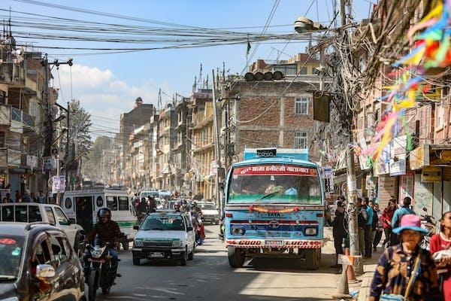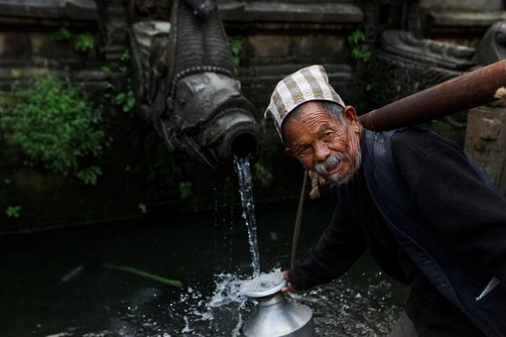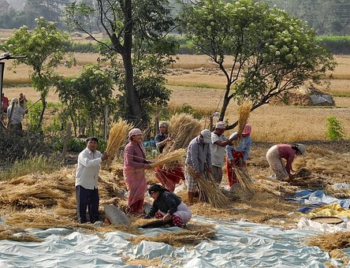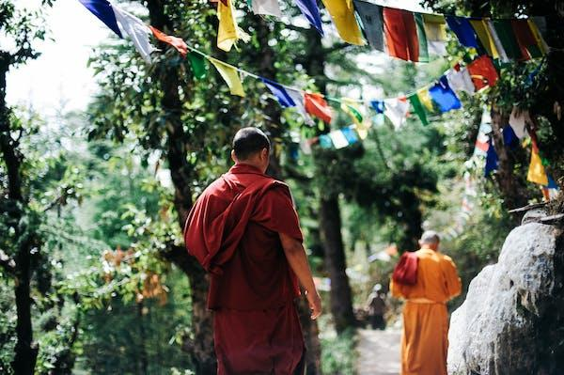

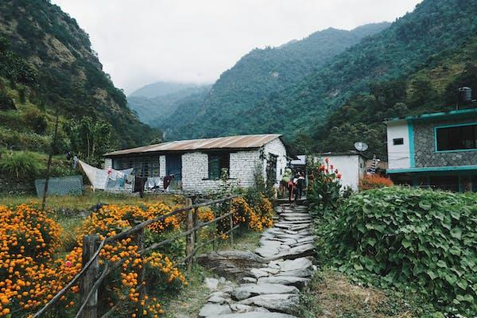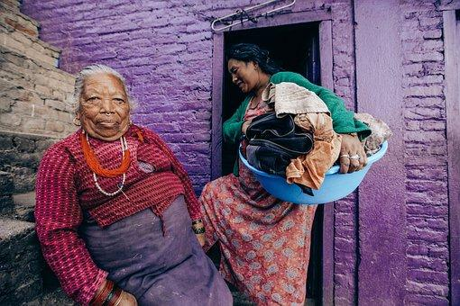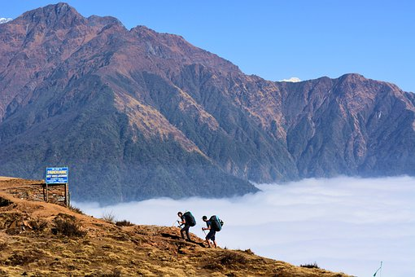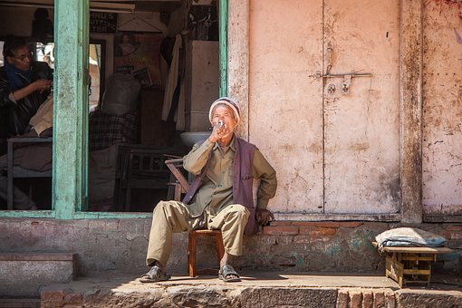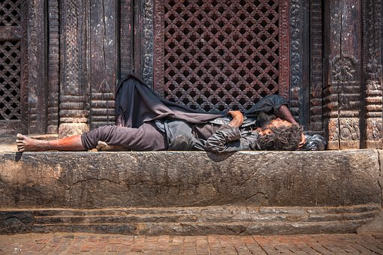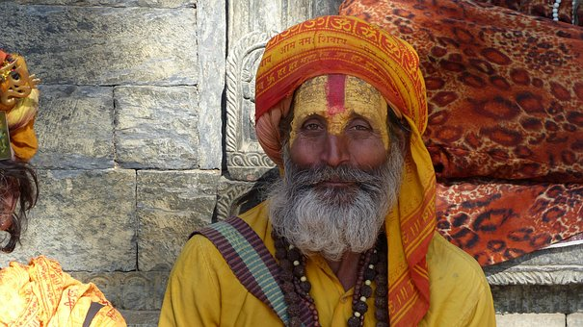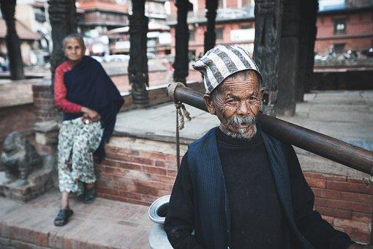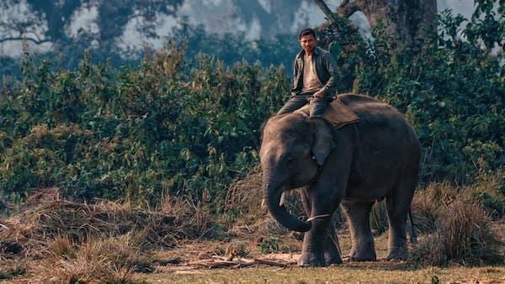

**PROJECT 8**

A Project work on the History of Amar Singh Thapa

**TABLE OF CONTENTS**

| **S.N.** | **Name of Contents** | **Remarks** |
| --- | --- | --- |
| **1.** | **Introduction to Amar Singh Thapa** |  |
| **2.** | **Personal Life and Family** |  |
| **3.** | **Contributions done by Amar Singh Thapa** |  |
| **4.** | **Achievements Achieved** |  |
| **5.** | **Conclusion** |  |

**1. Introduction to Amar Singh Thapa:-**

Amar Singh Thapa Chhetri was a Gorkhali military general, governor and warlord in the Kingdom of Nepal. He was the overall commander of the Nepal Army in the conquest of Western Provinces and authoritative ruler of Kumaon, Garhwal in the Kingdom of Nepal. He was referred by the King of Nepal to have been deployed as Mukhtiyar (equivalent to Prime Minister) of Western Provinces of Kumaon, Garhwal He is often hailed as Living Tiger of Nepal and he was posthumously regarded as one of the national heroes of Nepal, who led the Anglo-Nepalese War for the Gorkhali Army. Amarsingh Chowk Pokhara and Shree Amarsingh Model Higher Secondary School are named after the name of Amar Singh Thapa. He was born in 1751 A.D. (1808 B.S.) Sirhanchowk, Gorkha District.

He was a brave military commander during the anglo war, Nepal war of 1814-16AD. His father was also a brave gorkha soldier at the time of Prithivi Narayan Shah. He was a true patriot of our country. His role was vital for the unification of “Chaubise and Baise states”. During Anglo-Nepal war he was the incharge Nalagadha, Ramgadha and Gadwal forts. While the British general Octorlony attacked Ramgadha with a large army and canon, He bravely defeated the British Army. Then general Octorlony had to retreat Octorlony had tempted Thapa by offering the property but he refused it.

**2. Personal Life and Family**

He was grandson of Ranjai [of Sirhanchowk] and son of Bhim Sen known as Umrao Bagh Bhim Singh Thapa, who commanded and died in the battle of Palanchowk in 1759 AD. He belonged to Bagale Thapa clan. He was popularly named "Amar Singh Thapa (Bada)" to distinguished from another Kaji Amar Singh Thapa (Sana), Mukhtiyar Bhimsen Thapa's father, by identifiers "Bada" and "Sana" meaning elder and younger. His family members were added to the Royal Court by Bhimsen Thapa, who was also a member of Bagale Thapa clan. His eldest son Ranadhoj Thapa was deputy to Mukhtiyar (Prime Minister) Bhimsen Thapa sharing the authority while other four sons namely – Bhaktabir Singh, Narsingh, Ramdas and Ranjore Singh, all of them were Kajis at some point. His youngest son Ranajor Singh Thapa fought with him in the Anglo-Nepalese War while his eldest son Ranadhoj Thapa, was vice to Mukhtiyar of Nepal. His grandson, young Surat Singh Thapa, was appointed to post of Kazi in 1832 A.D. to retaliate growing Darbar politics after which the government papers were jointly signed by Mukhtiyar Bhimsen Thapa and Kazi Surath Singh. His two grandsons from eldest son Ranadhoj Thapa, namely – Ripu Mardan and Badal Singh, were both Kaji at some period. Thus, his family was another influential Bagale Thapa family in the Royal Court alongside the premier Bhimsen Thapa family.

**3. Contribution made by Amar Singh Thapa:-**

**In Sino-Nepalese War**

Bada Amar Singh led many conquest battles of Western provinces in the Unification of Nepal. He was leading the conquest of Langur Gadhi in Gadhwal Region before the outbreak of second Sino-Nepalese War (1791–92 A.D.). He reinforced back to Nuwakot travelling around 1000 km in about a month, in defence of Nepalese forces during the second Sino-Nepalese War of 1791–92 A.D. In July 1804, he along with Kaji Dalbhanjan Pande informed the Company's in-charge Daroga about the orders of takeover of Butwal plains and continuation of honoring Palpa's former obligations from the King of Gorkha. After 1806, the territories of Palpa were kept under the military governorship of him and Kaji Dalbhanjan. They set up plans to establish the full Gorkhali authority over the lands by appointing officials and reviewing land grants.

**In Anglo-Nepalese War**

The British columns led by British Generals Rollo Gillespie and David Ochterlony in the Western front faced the defence under the command of Bada Amar Singh. During the first campaign of Anglo-Nepalese War, Badakaji Amar Singh commanded Nepalese army facing columns under Major-General Rollo Gillespie and Colonel David Ochterlony in the Western Front (Kumaon Gadhwal axis). He commanded Gorkhali forces to defend the town of Srinagar from The third division army under Major-General Gillespie coming from western side. His son Ranjore Singh Thapa was holding forces at Nahan, the chief town of Sirmaur.

**Heritages built**

Amar Singh was a religious personality who built many forts across Nepal and India. The original Gangotri Temple at Uttarakhand was built by him, which is part of Chhota Char Dham pilgrimage circuit. He built the oldest temple in the Mithila city Janakpur, Nepal, the Sri Ram Temple. After establishment of full Gorkha authority over Palpa and adjacent Terai, he built the Amar Narayan temple at Tansen in the hills above Butwal in 1807.

**4. Achievements achieved:-**

Bada Kaji Amar Singh is often hailed as Living Lion of Nepal due to his fighting prowess, greater leadership and patriotism. British Historian Hamilton drew comparisons of him with the ancient Carthaginian General Hannibal. A popular patriotic quote in the Nepalese history is attributed to him: Ma Bagh ko Damaru hu, malai sino khane Kukur nasamjha. The letter from the central government of Nepal held the praises of Kaji Amar Singh in the letters to other civil and military officers including provincial governors: Kaji Ambar Simha Thapa is old and mature, and also true to his salt. Act according to his advice. -Appointment letter of one-third Subba of Garh Chandrabir Kunwar Ashadh Badi 2, 1862 V.S. The village of Amaragadhi in western Nepal is named for him. There is a Khukuri sword named after him called Amar Singh Thapa Khukuri. This Khukuri is modeled on the real Khukuri used by him. The real Khukuri used by Amar Singh is archived at National Museum of Nepal and is more curvy in nature than other traditional Khukuris.

**5. Conclusion:-**

From the study of biography of Amar Singh Thapa, we can conclude that he was a brave, patriotic and fearless warrior in the history of Nepal. His contributions are still remembered in the heart of Nepalese people. If he wasn't there, we would have to live like slaves under the foot of foreign invaders. Nobody can never ever forget about him and his contributions that made Nepal walk in a golden path. All the new generations should also know about him and become inspired through his bravery.